HIRING: Head of Sales – INDIE RABBLE BREW Co

Head of Sales– Indie Rabble Brew Co

Indie Rabble Brew Co, established August 2023 are now hiring to take the next, biggest, and most exciting step to date in the history of our young brewery.
We are looking for a well-established, well known industry professional to take complete ownership of our sales strategy, reporting to our co-owner and Director of Operations, establishing a formal sales function for the first time.
In the first year, you would be expected to deliver growth in the national on-trade, as well as establish initial KPIs for the brewery. Your role would be primarily sales and account management – with four core focuses:
- Generate new on-trade business
- Entrench and develop existing business through
  - direct engagement with heads of our customer businesses,
  - customer facing events,
  - and incentives such as line tie discounts
- Successfully complete on initial in-roads made toward the export market, bringing our smallpack offer to a European audience
- Develop, expand, and foster strategic importance of our brand and beer with our existing and potential new wholesale customers
In year 2, you would be expected to recruit, with the support of the owners, someone to head up telesales and email to support our customer network, as well as establish for the first time a direct dray network, formalising what is at the moment a best-endeavours process run by the directors ourselves.
Beyond these initial goals – our direction is as much your choice as our plan. We are looking to hire someone to champion us, build us, and have a career with us at what we hope to be one of the UK’s most exciting small breweries.

About you
This is a dynamic role working directly with the company owners and directors to drive Indie Rabble Brew Co from a new, well regarded and relatively widely available given our limited resources – to a business over the next 2-3 years that is seen as a genuine agitator to the largest UK independent breweries.
As such it requires someone with a proven track record, a significant existing contact book, and both the drive and personality to gain us these in-roads.
You will be a partner to the four of us as co-owners, and in time potentially shareholder also.

Key Requirements
- Proven Sales Leadership: At least 2 years of experience leading sales, within a brewery that understands modern craft trends
- Strategic Planning: Ability to develop sales strategies that align with growth targets and our brand values, as well, indeed, as to initially set said targets based on our first 18 months.
- Analytical Expertise: Skilled in interpreting and analyzing sales data to inform decisions.
- Detail-Oriented Mindset: A keen eye for detail and an appreciation for the small things that make a big difference.
- Passion for Beer: Enthusiastic about beer, with a strong understanding of beer styles and industry trends.
- Networking and Collaboration: Skilled at building industry relationships and introducing innovative ideas and best practices.
- Team Player: Very welcoming of a collaborative approach to ensure alignment across sales, marketing, and brewing teams.
- Flexibility: Willing to pitch in across various brewery operations, as is often needed in a small business setting.
- Interpersonal Skills: Outgoing and approachable, with the ability to represent the brand positively.
- Communication: Strong written, verbal, and listening skills to communicate effectively.
- Driving Eligibility: A driving license would be strongly preferred owing to the need to canvas and prospect on account, in person
- Business Development: Ideally you can evidence that the growth journey outlined above is something you’ve gone through before, in this or another field.
We are a startup – and this is only the second full time hire outside of our taproom manager. It’s a big deal for us, and growing from these small seeds is make-or-break for our business. You will be critical to it.

About us
Indie Rabble opened to the public in August 2023 after 3 years of planning: starting in the garden of nearby Micropub A Hoppy Place and culminating in the mass upscaling of initial plans by head brewer Alex Rowlands and his then fiancé Alison to brew 150 litre batches in his shed and sell a few kegs around Berkshire…
We settled on a 20HL electric brewhouse along with 6x 2200 litre CCVs, from which we package into keg, can, and occasionally cask. We have plans to expand, and sales are the critical driver for that. 3 more 20HL fermenters are planned, with an option on a 40HL in addition.
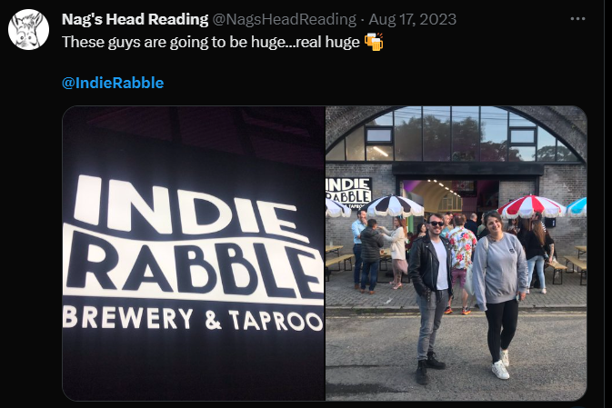
So far, we’re just outside of the top 50 UK microbreweries according to Untappd and have just celebrated our 10,000th Untappd checkin.
We are SIBA’s best new UK Brewery 2024 and were nominated for best new brewery at Brewer’s Congress also.
We have attended the big 3 beer festivals and a half dozen others, and have an exciting name that attracts a crowd.
We brewed 800HL in 2024 and aim for this to be at least 1400HL in 2025.

The package
- 40 hours a week
- 4.5 days per week (flexible)
- A generous beer allowance from each packaging run
- Friends and family discount
- Sample product as required, in order to sell
- Pension via NEST
- 28 days holiday per year (incl bank holidays)
- Salary:
  - £38,000-45,000 depending on experience
  - This is a non-commission based role, however, as we effectively want a partner to drive this business forward, we are very open to offering a share in this business once KPI’s have been set and then met. We want to drive Indie Rabble forward together.
- We’d like you to start immediately, but appreciate you may have a longer notice period, and can be flexible with this as necessary.
If this is of interest, please get in touch! Contact beer@indierabble.co.uk with a CV and covering letter and let’s have a conversation.

